# Vector Databases

Youtube video: <https://youtu.be/dN0lsF2cvm4>

# General Flow-

# Unstructured Data can’t be fit into RDBMS

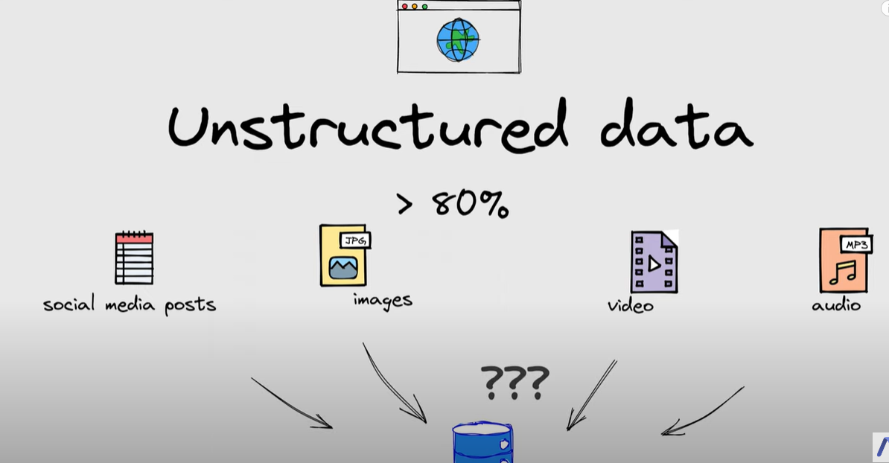

# Definition

A vector database indexes and stores vector embeddings for fast retrieval and similarity search.

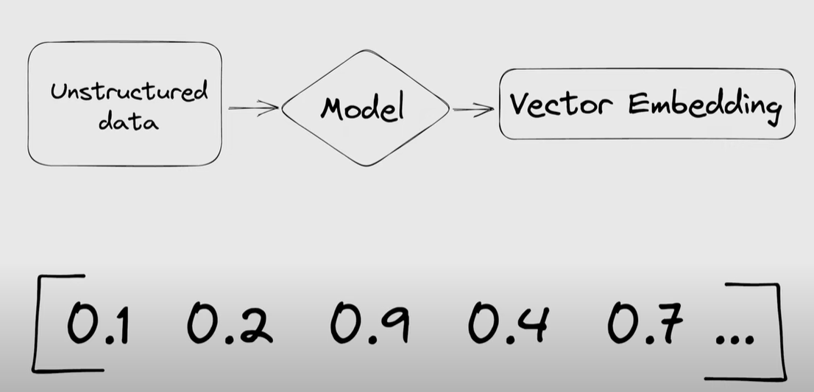

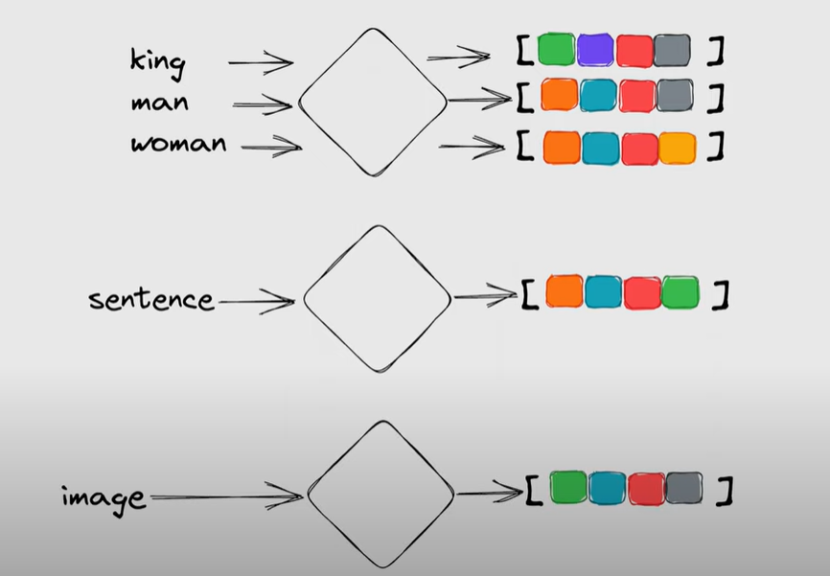

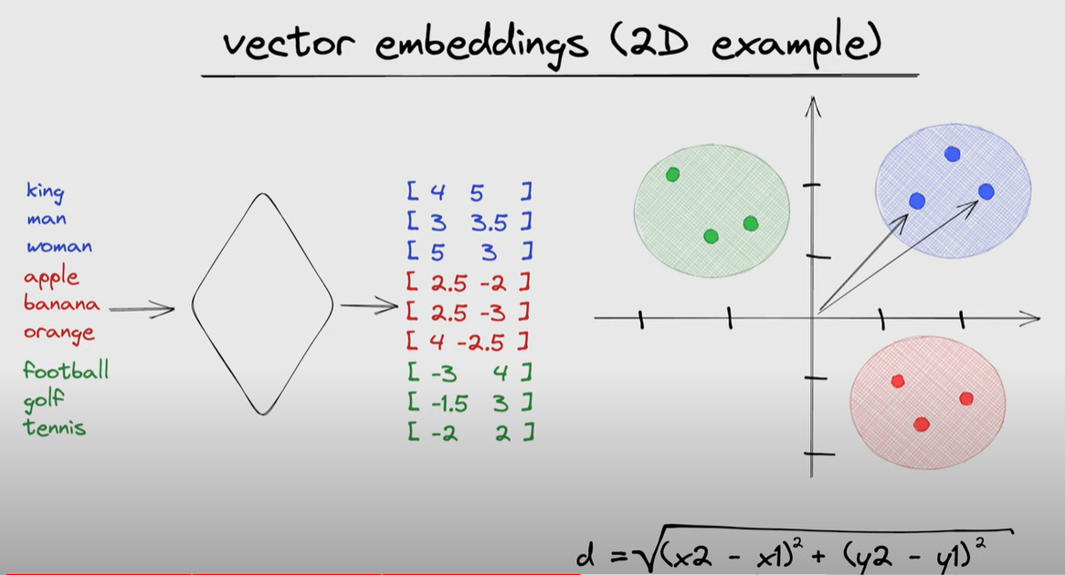

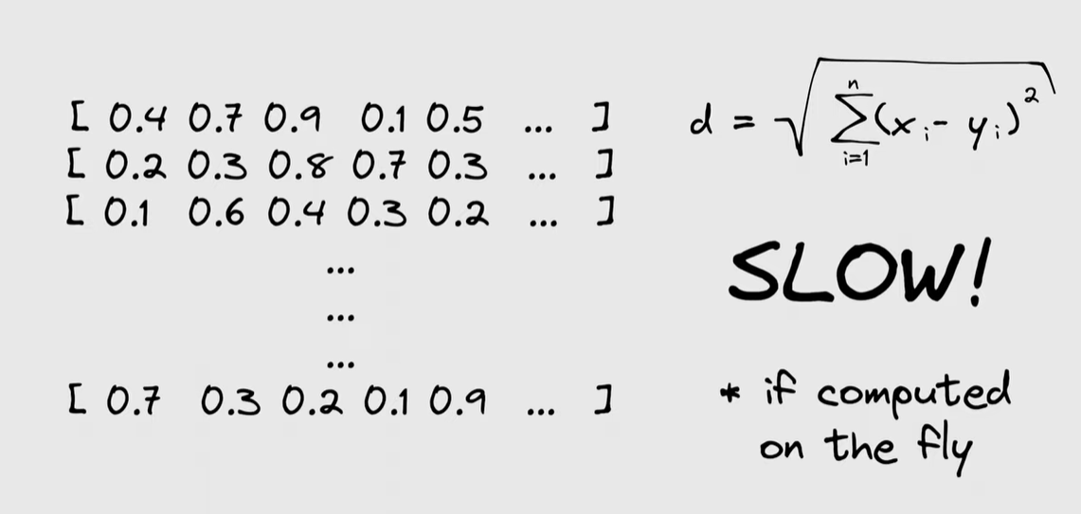

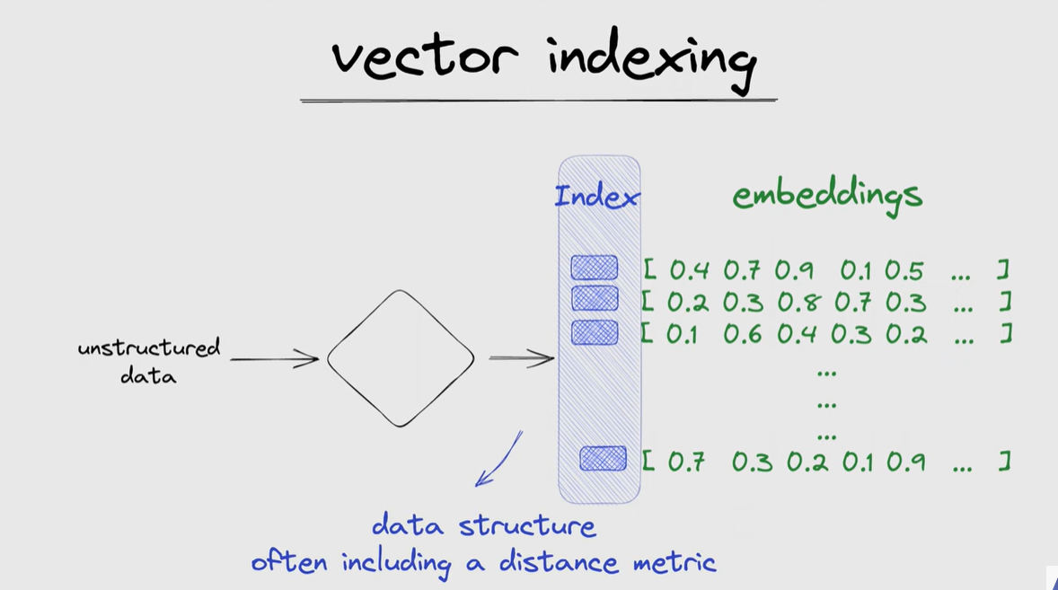

# Use Cases of Vector databases-

